ESP32 + N706B-CN OTA Design
Oct 30, 2026 · @Ved
The ESP32-WROOM-32E can update its own firmware over 4G through the N706B-CN, writing a new image into the inactive OTA slot and rolling back automatically if the new image fails. The code targets ESP-IDF in a PlatformIO project.

Goal and scope
- In scope: version check, firmware download over the cellular link, write to the inactive slot, integrity check, reboot, self-test, mark valid or roll back.
- Out of scope for now: delta updates, updating the modem's own firmware, and secure boot / flash encryption (noted as later hardening).
- Decided: ESP-IDF framework; design before code; both modem-side HTTP(S) download and PPP are candidates.
- Not decided: where the firmware is hosted.

Hardware and flash layout
The current partition table already supports OTA, and any firmware image must stay under 1920 KB to fit a slot.
Partition | Offset | Size | Role in OTA
nvs | 0x9000 | 20 KB | Stores update state, version, retry counters
otadata | 0xe000 | 8 KB | Bootloader reads this to pick the active slot
app0 (ota_0) | 0x10000 | 1920 KB | Firmware slot A
app1 (ota_1) | 0x1f0000 | 1920 KB | Firmware slot B
spiffs | 0x3d0000 | 128 KB | Not used by OTA (can hold the manifest cache or logs)
coredump | 0x3f0000 | 64 KB | Crash dumps for debugging failed updates
- Link: the N706B-CN is an LTE Cat.1 module (about 10 Mbps down, 5 Mbps up per a distributor listing), connected to the ESP32 over a UART with AT commands.
- UART speed matters: at 115200 baud the ESP32 can read about 11.5 KB/s, so a 1.9 MB image takes roughly 170 seconds. At 921600 baud it is about 21 seconds. Both figures are theoretical maxima; real throughput will be lower.
- Factory slot: with a table that has no factory partition, the first flash puts firmware in app0 and OTA alternates between app0 and app1.
- Safety rule: OTA code must only write to the partition returned by esp_ota_get_next_update_partition(). It never touches the bootloader at 0x1000 or the partition table at 0x8000, which is what a full chip erase wiped earlier in testing.

Transport options
Start with Option B (PPP) if the N706B-CN supports it, because it reuses the standard ESP-IDF OTA code. Keep Option A as the fallback if the modem's own HTTP(S) download is easier to get working.
 | Option A: modem downloads, ESP32 reads over UART | Option B: PPP, ESP32 runs the network stack
How it works | ESP32 sends AT commands telling the modem to fetch the URL; the modem buffers the data; ESP32 reads it in chunks and writes each chunk with esp_ota_write() | esp_modem dials the modem into data mode (PPP); the ESP32 gets an IP interface and uses esp_https_ota like on Wi-Fi
Code to write | Custom AT parser, chunk reader, resume logic | Mostly configuration; esp_modem handles dialing and PPP
TLS | Done by the modem (depends on its supported TLS versions and certificate handling) | Done by mbedTLS on the ESP32 (certificate bundle or pinned cert)
Resume after drop | Needs HTTP Range support through the modem's commands | esp_https_ota can resume with a partial-download setup; Range works end to end
RAM / CPU load on ESP32 | Low | Higher (PPP + TLS), fine for WROOM-32E
Main risk | AT command limits (max chunk size, buffer, timeouts) are unknown until we read the N706 manual | Modem must support PPP dial (usually ATD*99#), which needs confirming
- Both paths share: manifest check, SHA-256 verification, rollback logic, and the same slot handling. Only the "get bytes" layer differs.
- Design choice: put the download behind one small interface (open, read, close, size) so the OTA state machine does not care which option is used.

Update flow
An update becomes permanent only after two checks: the image verifies before the reboot, and the app proves itself after it.
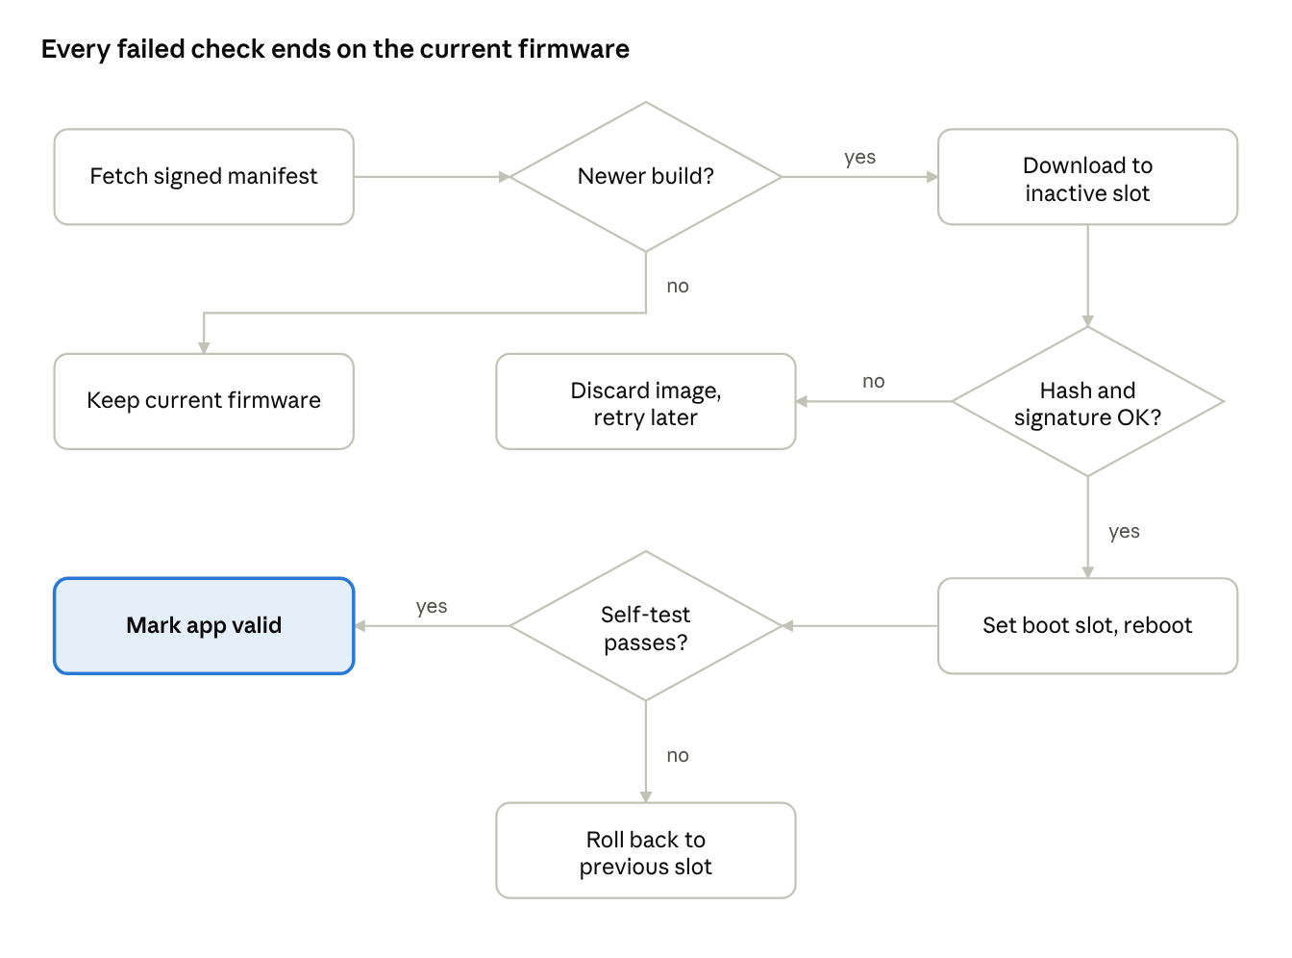
OTA update flow · 3 checks, 3 safe endings
The slot is the only thing the update writes to, and the old image stays intact until the self-test passes. How often the device checks the manifest (at boot, on a timer, or on a command) is still to be decided.

Integrity, security and rollback
A failed or tampered update must never leave the device unable to boot, so every update is checked before it is activated and confirmed after it boots.
- Size check: read the image size from the manifest and refuse anything above 1920 KB before writing a byte.
- Hash check: compute SHA-256 while writing and compare it with the manifest value before calling esp_ota_set_boot_partition(). esp_ota_end() also validates the image header and checksum.
- Authenticity: sign the manifest (for example Ed25519 or ECDSA) and keep the public key in firmware. A hash alone only protects against corruption, not a malicious server.
- Transport security: use HTTPS with a pinned certificate or the ESP-IDF certificate bundle. Plain HTTP is acceptable for bench testing only, and only if step 3 is in place.
- Rollback: enable CONFIG_BOOTLOADER_APP_ROLLBACK_ENABLE. After the first boot of a new image, run a self-test (modem registers on the network, UART and Modbus tasks start), then call esp_ota_mark_app_valid_cancel_rollback(). If the app crashes or resets first, the bootloader returns to the previous slot.
- Anti-downgrade: compare versions (or a monotonically increasing build number) and refuse older images unless explicitly allowed.
- Retry limit: store an attempt counter in NVS so a bad URL or flaky signal does not retry forever or burn mobile data.
Secure boot and flash encryption are not part of this first version because they are one-way eFuse changes. They can be added later without changing the OTA flow.

Hosting and manifest
Hosting is undecided; the simplest start is a small HTTPS file store with a signed JSON manifest next to the binary.
Option | Good for | Watch out for
Object storage with HTTPS (S3, GCS, R2 or similar) | Production; cheap, supports Range requests | Certificate handling on the modem or ESP32; signed URLs expire
Your own server (nginx on a VPS) | Full control, easy logging | You run and secure it
Local PC server (python3 -m http.server) | Bench testing on a hotspot or tunnel | Not reachable from the field; plain HTTP
FTP | Only if the N706 FTP commands are easier than HTTP | Unencrypted by default; weaker for production
The device downloads a small manifest first, and only downloads the firmware if it describes a newer, valid image:
{
"version": "1.2.0",
"build": 42,
"url": "https://example.com/fw/firmware-1.2.0.bin",
"size": 1048576,
"sha256": "<64 hex chars>",
"signature": "<base64 signature over the fields above>",
"min_version": "1.0.0"
}
The values above are placeholders, not real files. The check uses build so versions compare as plain integers.

Open questions
Most of these depend on the N706 AT command manual, which I could not find online; the only Neoway manual I could open covered the older N20 module. Please share the N706B-CN AT manual or datasheet.
- ☐ Does the N706B-CN support PPP dial-up (ATD*99#) with the ESP32 as the host?
- ☐ Does it have built-in HTTP(S) AT commands, and what are the limits on chunk size, buffer size and timeouts?
- ☐ Which TLS versions and certificate options does the module support (for Option A)?
- ☐ Can the UART run at 460800 or 921600 baud reliably on your board, and are RTS/CTS flow-control lines wired?
- ☐ Which wires connect the modem (TX, RX, power key, reset, status) to which ESP32 pins?
- ☐ Which SIM / APN will the device use, and is there a data cap per month?
- ☐ What is the real firmware size today, and how much headroom is acceptable under 1920 KB?
- ☐ Where will the firmware be hosted, and who signs releases?
- ☐ Is the Modbus meter task allowed to be paused during an update, or must it keep running?

Milestones and test plan
Build in five steps, proving each on the bench before the next, so a failure points to one layer.
Step | Deliverable | Pass criteria
1. Modem bring-up | Power sequencing, AT link, SIM check, network registration, APN attach | AT returns OK; module registers on the network; data session opens
2. Download test | Fetch a known file (a few hundred KB) by the chosen transport | Byte count and SHA-256 match the source file
3. OTA write | Write the file into the inactive slot with esp_ota_*; set boot partition | Device boots the new image; otadata switches slot
4. Safety | Manifest + signature check, rollback enabled, retry counter, power-loss handling | Bad hash, bad signature, truncated download and reset mid-write all leave the old image running
5. Field trial | Full flow on real signal, with logging to NVS or coredump | Several updates in a row succeed, including a weak-signal retry
Negative tests to run before trusting it:
- Pull power at 10%, 50% and 99% of the download.
- Serve a file with one flipped byte.
- Serve an image larger than 1920 KB.
- Flash a build that crashes on boot and confirm it rolls back.
- After each test, dump 0x1000 and 0x8000 to confirm the bootloader and partition table are untouched.

